Pervomaiskyi, Kharkiv region

Production of evaporated food grade salt

Technical and commercial proposal

Director of NIOCHIM I.H. Dovhaliuk

2015

CONTENT
1 General provisions 3
1.1 Subject of the proposal 3
1.2 Construction area, composition of production 3
2 The technological process and the level of technical support for the production of evaporated food grade salt 3
2.1 Progressive solutions for the production of salt, grade "Extra" 3
2.2 Production capacity 4
2.3 Feed quality 4
2.4 Final product quality 4
2.5 Process description 5
2.6 The list of main technological equipment 7
2.7 Consumption indicators of the main types of feedstocks, materials, energy……………….8
2.8 Wastes of production 8
2.9 Number of staff 8
2.10 The layout of production facilities 8
2.11 Process automation 9
3 Construction implementation cycle 12
4 Estimated project implementation costs 12

1 General provisions

1.1 Subject of the proposal

The subject of this Proposal is the construction of production of evaporaed food grade salt with a capacity of 50 thousand tons per annum.
Given the current state of the site of the former State Enterprise "KHIMPROM" and its infrastructure after the liquidation of the enterprise, it can be concluded that there are prospects for reconstructing individual industries based on local raw materials and availability of energy resources.
The most promising, due to objective conditions, is the creation of the production of evaporated (food grade) salt based on the existing sodium chloride raw material (brine wells).
Production Method: The extraction of crude brine is carried out by the method of stepwise directed leaching of sodium chloride through boreholes.
The designed brine extraction capacity is 870,000 m3 / year.
The total area of brine extraction station is 14.7 hectares. The brine station is located 10 kilometers from the main industrial site of the enterprise. Crude brine is fed to production through an underground pipeline.
The main mineral composing the deposit is coarse-grained halite. A feature of the rock salt deposit is its monominerality.
The total number of brine extraction wells in the brine station of the enterprise is 7. Wells have a depth of 1200 meters and are located at the vertices of a quadrangle in shapes close to a rhombus with a side of 175 meters.
The brine extraction station provided the chemical chloralkaly production with a saturated brine of 315 g / liter in an amount of 150 m3 / h, which is more than 400 thousand tons per year of pure sodium chloride. Production of the indicated volume was achieved due to the simultaneous operation of only two wells, meanwhile the remaining 5 were in reserve or under maintenance.
The average sodium chloride content of the solution is 99.3%.

1.2 Construction area, composition of production

Pervomaiskyi, Kharkiv region.

Salt production includes:
• industrial building;
• packing department;
• warehouse of the finished product.

2. The technological process and the level of technical support for the production of evaporated food grade salt

2.1 Progressive solutions for the production of salt, grade "Extra"

1. The use of a local system steam generator as a heat source installed directly in the production of table salt and replaces the bulky boiler plant. With this arrangement of equipment, heat loss to the environment is significantly reduced. The consumption of natural gas for receiving 1 ton of steam does not exceed 76 m3, electricity - 3.75 kWh, feedwater makeup - 0.8 m3. The steam generator is equipped with a full automatic process control system.

2. The hardware-technological scheme for the production of table salt involves the use of heat exchange equipment for the use of secondary energy resources (secondary steam condensates).

3. Instead of expensive titanium, a stainless steel construction material for table salt production equipment was selected, which can significantly reduce capital costs for the purchase of equipment.

2.2 Production capacity

The production capacity is determined in the amount of 50 thousand tons per year. If operating at 8000 hours per year, the production will amount to 150 tons per day or 6.25 tons per hour, with allowance made to possible doubling of capacity to 100 thousand tons per year.

2.3 Feed quality

The average composition of the purified brine is characterized by the following data (% wt.).
NaCl - 25.5%
H20 - 74.5%
specific gravity 1.197 kg / dm3.

2.4 Final product quality

Physico-chemical indicators of salt are shown in table 1.
Table 1
Name of indicator | Norm on dry substance grade
 | extra | top
Mass fraction of sodium chloride,%, not less than | 99,50 | 98,20
Mass fraction of calcium - ion,%, not more than | 0,02 | 0,35
Mass fraction of magnesium - ion,%, not more than | 0,01 | 0,08
Mass fraction of sulfate - ion,%, not more than | 0,20 | 0,85
Mass fraction of potassium - ion,%, not more than | 0,02 | 0,10
Mass fraction of iron oxide (III),%, not more than | 0,005 | 0,040
Mass fraction of sodium sulfate,%, not more than | 0,20 | not applicable
Mass fraction of water-insoluble residue,%, not more than | 0,03 | 0,25
Mass fraction of moisture,%, not more than | 0,10 | 0,70

By agreement with consumers, salt may be produced with the addition of iodine, fluorine, as well as with an anti-caking additive.
The volume of salt production by grades is adopted in the following ratio: 80% - "Extra" grade salt, 20% - "top" grade.
Salt is packaged in bags weighing 25 kg - 50% of the annual production volume and 50% - in plastic bags weighing 1 kg.
At the request of consumers, salt can be shipped in disposable containers.

2.5 Process description

The production flow chart is presented on page 6.
The purified brine from the brine collector is fed through heat exchangers to the evaporation unit, where it is evaporated “onto the crystal”.
From the salt collector of the housing assembly the salt pulp is fed into the thickener.
From the thickener the thickened salt suspension is fed to a centrifuge, where the salt is separated from the mother liquor. The clarified part from the thickener and the mother liquors of the centrifuges are mixed with the starting brine and fed to the evaporation.
In order to ensure the normative amount of sulfate-ion in the finished product, the evaporated solutions are periodically discharged from the evaporator.
The salt separated by centrifuges is dried in a drum dryer, dispersed and fed to packaging in bags (containers) and plastic bags.
Packed salt is transported to the finished goods warehouse, following which it is sent to consumers.
Steam production is provided from a steam generator.

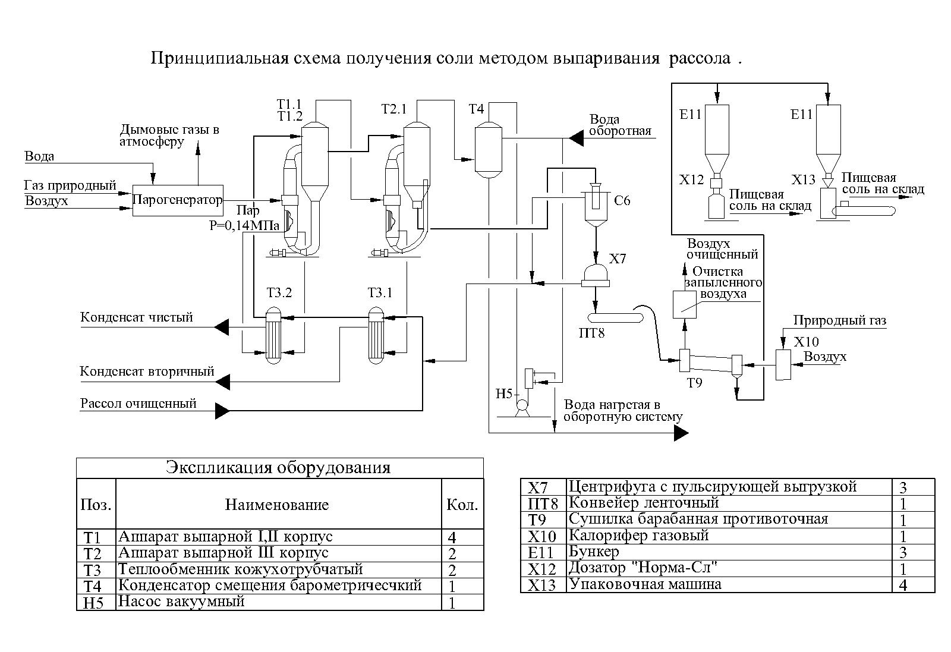

2.6 The list of main technological equipment

The list of main technological equipment is presented in table 2.
Table 2
The list of main technological equipment
Schema position | Name | Number,  pieces | Material | Unit weight, kg
Т1 | Evaporating apparatus of the housing assembly I, II with forced circulation | 4 | Alloyed steel | 40000
Т2 | Evaporating apparatus of the housing assembly III with forced circulation and salt extractor | 2 | Alloyed steel | 40000
Т3 | Shell-and-tube heat exchanger | 2 | Alloyed steel | 5550
Т4 | Barometric mixture condenser | 1 | Alloyed steel | 1700
Н5 | Liquid ring vacuum pump | 1 | Q = 50 m3 / min.  Material: precast | 3000
С6 | Thickener | 1 | Alloyed steel | 19000
Х7 | Pulsed discharge centrifuge | 3 | Q = 3 - 3.5 t / h  Material: precast | 2050,  including titanium 100
Т9 | Countercurrent drum dryer with loading and unloading chamber | 1 | Carbon steel | 36100
Х11 | “Norma-SL” dispenser for bagging | 1 | Q = 800 bags / h
Х12 | Packing machine for bags up to 1 kg | 4 | Q = 30 pack. / min  Firm "Mashek", Czech
 | Steam generator (including: boiler, economizer, burner, smoke exhaust, fan, Electrical Control & Instrumentation, steam and water fittings) | 1 | Q = 15 t / h;  P = 0.14 MPa  Dimensions: 8655x5200x6053mm

2.7 Consumption indicators of the main types of feedstocks, materials, energy

The consumption indicators of the main types of feedstocks, materials, energy resources are presented in table 3.
Table 3

Name | National State Standard, grade | Unit of measurement | Consumption
 |  |  | per 1 t 100% NaCl | per annum
1 Purified brine 310 g / dm3 NaCl |  | m³ | 3,8 | 190000
2 Steam 0.14 MPa |  | Gcal | 0,85 | 50000
3 Natural gas |  | nm³ | 12,0 | 600000
4 Technical water |  | m³ | 0,4 | 20000
5 Electric power |  | kWh | 64,0 | 3200000
6 Process water |  | m³ | 39,5 | 1975000
7 Paper bags (for packaging by 25 kg) | ГОСТ  2226-88 | pcs | 41 | 1025000
8 Food polyethylene film | ГОСТ  10354-82 | kg | 11 | 275000
9 Shrinkable film | ГОСТ  25951-81 | kg | 5 | 125000

2.8 Wastes of production

To ensure the regulated quality of the finished product, it is necessary to periodically discharge working solutions from the evaporator.
The quantity of waste mother liquors is 0.591 tons per 1 ton of salt produced or 29550 tons per year.
The average composition of waste mother liquors,%: NaCl - 24.8, Na2SO4 - 3.27, other impurities - 0.49, water - 71.4.

2.9 Number of staff

The number of staff in the production of evaporated food grade salt is 48 people, including:
engineering and technical workers and employees 8 people;
main workers 28 people;
auxiliary workers 12 people.

2.10 The layout of production facilities

On page 10 one of the possible layout options for the production of evaporated food grade salt is shown, including:
• production building 51 × 24 × 30 m;
• finished goods warehouse 39 × 24 × 7.2 m.

2.11 Process automation

For the production of evaporated food grade salt, it is proposed to create an automated process control system.
The process control system is designed to solve the problems of managing technological processes in order to maintain their continuity, increase production efficiency by stabilizing the parameters of the technological regime in the framework of regulatory standards, which will reduce the unit costs of material and energy resources, and produce products of a given quantity.
The control system is equipped with a set of technical means, including primary converters, pneumatic-actuated control devices, microprocessor controllers, network equipment and personal computers.

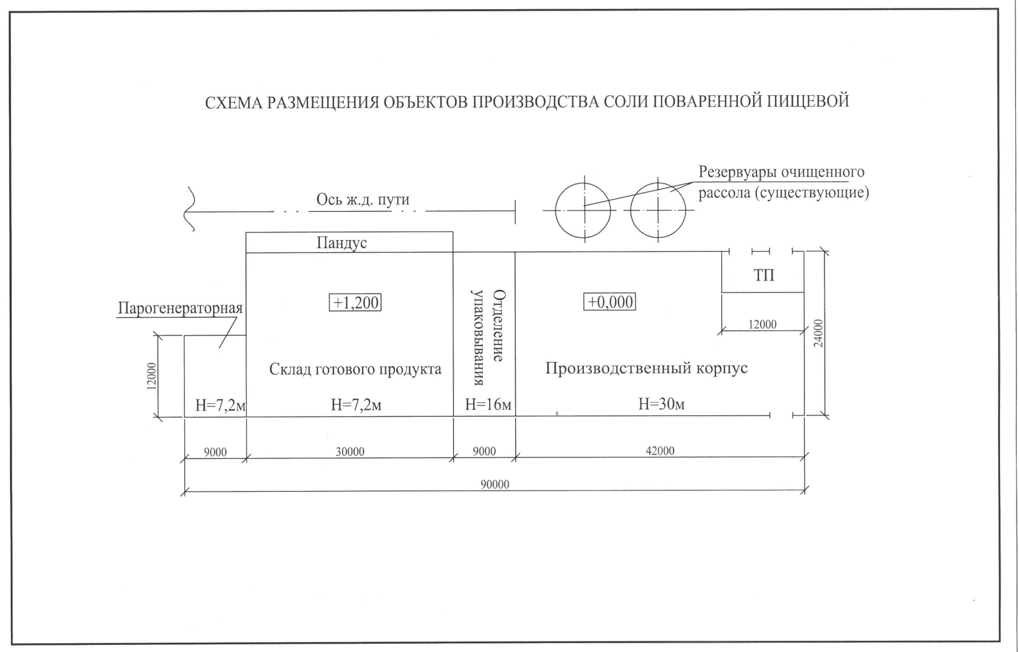

Placement of the production of evaporated food grade salt
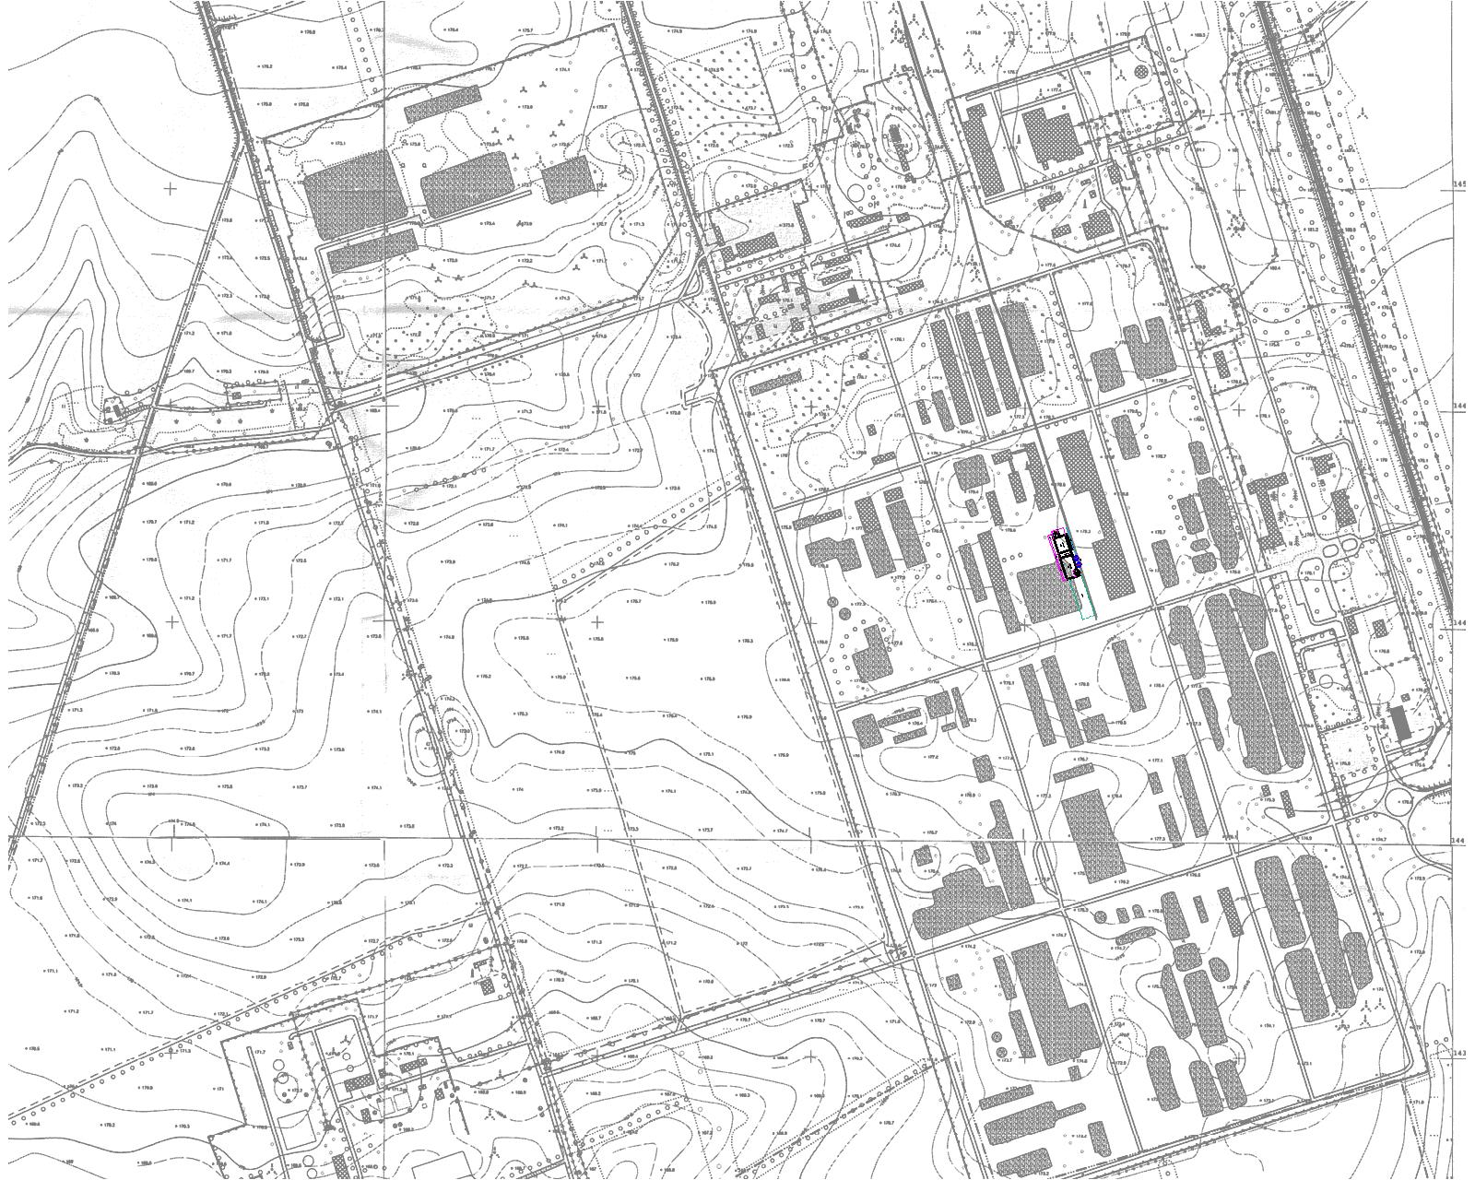

3. Construction implementation cycle

The implementation cycle of the construction of production consists of stages that are important activities in the implementation of the project as a whole. The total duration of the construction of production is determined at 24 months.

4. Estimated project implementation costs

- Estimated cost of construction - 8 million USD.
Production construction schedule
# | Name of stages and objects | Duration in months
 |  | 1 - 2 | 3 – 4 | 5 - 6 | 7 - 8 | 9 - 10 | 11 - 12 | 13 - 14 | 15- 16 | 17 - 18 | 19 - 20 | 21 - 22 | 23 - 24
1  2 | Research  Design and survey work
3 | Supply of building metal structures and materials
4 | Supply of pipelines and fittings
5 | Supply of equipment, instruments and devices
6 | Construction works
7 | Installation work
8 | Commissioning works
9 | Start

